AT-PIC

Automated Testing of Integrated Photonics Chips

Final-project Report

Fall Semester 2023

Senior design team members:

Ali Algedheebi, EE

Ben Morrison, EE

Gavin Looney, EE

Trent Fleming, EE

Other team members :

Mirza Mirza Baig, CE

Graduate Advisor

Department of Electrical and Computer Engineering Colorado State University

Fort Collins, Colorado 80523

Project advisor(s):  *Prof. Mahdi Nikdast*

Approved by:

Date of approval:

# ABSTRACT

Silicon photonics is a rapidly growing field in the world of microelectronics, especially in computing power. A main bottleneck in computing power is the limited bandwidth of the interconnects between various subsystems in a microprocessor. Silicon photonics inherently has a larger bandwidth due to its use of photons rather than electrons. At Colorado State University there is the Electronic Photonic Systems Design Laboratory (ECSyD) headed by Prof. Mahdi Nikdast. The research that this lab looks into is the design and implementation of emerging technologies for high performance computing. Photonic Integrated Circuits (PIC) is on the emerging technologies that Dr. Nikdast and his team look into. For them to explore these PIC’s they need a reliable and automated process to test physical chips. This leads to them using an automated test bench that allows them to test various photonic devices implemented on a chip. Currently the ECSyD lab has a manufactured automated test bench from Maple Leaf Photonic (MLP) Systems. With the amount of workflow that they have it has become imperative to accrue a second automated test bench. Many of the currently available to market test benches for photonics have price ranges in the tens to hundreds of thousands of dollars it was tasked to instead design and implement one of their own. This is our main objective as a group is to design and create an automated testing station for photonic integrated chips.

Specifically in this report we have and show the results of run testing for requirements on various devices included within the MLP test bench. We also have run some theoretical experiments into the optimization of various utilities within a silicon photonics testing bench. A review of the various components and devices, generously donated by Hewlett Packard Enterprises (HPE), was done to find the use case within the final design of the automated test bench for photonic systems. Finally we created a baseline to compare our results with our designed automated test bench with that of the commercial test bench.

Finally, we have created a design that can be used to integrate the various subsystems using LabVIEW as the integration platform. A single computer is used to integrate all of these devices into a single easy-to-use software. There is also a future work proposal explaining the various mechanical and electrical sections that need to be completed in order to fulfill the objectives of this project. This includes creating and designing the mechanical arms to be attached to each fiber stage as well as the inclusion of programming to design the underlying software as well as an user interface to interact with the test bench seamlessly.

# TABLE OF CONTENTS

Title i

Abstractii

Table of Contents iii

1. Introduction 1
2. Testing Station Design 3
   1. Early Testing on Maple Leaf System 3
   2. Hardware to be Used in Design 6
   3. Hardware Setup 9
3. Standards and Tools10
4. Conclusion11
5. Future Work12

References 14

Appendix A – Abbreviations15

Appendix B – Budget16

Appendix C – Project Plan Evolution17

Acknowledgments 19

### Chapter 1. INTRODUCTION:

Today, silicon photonics has shown potential to have important breakthroughs in fields such as telecommunications, computation, and data processing. In a world of rapidly increasing technology this is important as to not limit the potential of these various fields. Silicon Photonics is the process of using micro optical devices while still being able to use the CMOS fabrication standards of traditional microelectronic devices. As a result, significant improvement on the aspects of data transfer have been shown, which could result in speed and efficiencies which previously seemed unimaginable. Silicon Photonics is able to achieve this by using light as the aggregate carrier within a thin wafer of silicon. This contrasted to traditional microelectronics that use electrons on thin silicon wafers. First, this strategy increases data bandwidth while reducing energy, which is a critical requirement for efficient energy consumption worldwide. Dr. Nikdast’s ECSyD lab works to design and implement photonic integrated circuits. For them to actively test and verify various research projects within the silicon photonics field, they need a way to reliably test their circuits and log their results. This is where automated photonic testing stations are useful as they allow a team to accomplish this task.

Testing stations are very important for assessing reliability, performance, and scalability of silicon photonic components. With these technologies becoming more and more prevalent in different sectors, testing is geared towards ensuring that they meet the stipulated efficiency and effectiveness required. However, there are current and ongoing issues within the field of silicon photonics that hinder a future where data and telecommunication technologies will be fast, and effective. There are a few issues that can plague silicon photonics, mainly when it involves testing and characterization of their elements. Complex devices as waveguides, modulators and interferometers make this research into silicon photonics very important for improvement of communication systems, computer technologies, etc. Nevertheless, it is the efficiency of these photonic elements that is critical and testing for this efficiency must be precise and refined.

Since these components’ complexity usually defies traditional testing methods, it is important to have a standalone device that can test such devices. For example, testing waveguide characteristics to achieve low optical losses or modulator capabilities to achieve optimal control over optical light signals, requires different hardware than that of traditional microelectronics. Therefore, the testing of these components requires a special approach, since each device on a photonic integrated chip has its own unique characteristics. This response has led to the development of the integrated photonic testing stations. This includes highly accurate characterization for complex photonic devices, ability to change applied variation that photonic chips are susceptible to and automated process as usually a photonic chip will have thousands to hundreds of thousand devices. To achieve this a photonic testing station uses state of the art equipment to perform these highly precise evaluations. This tool allows researchers and engineers to pinpoint problems associated with the fabrication process, design oversights and to test their simulation process.

In this project we will develop an integrated silicon photonics testing station for the ECSyd lab featuring modifications targeted towards advance research and evaluation purposes. This new station will have a larger chip bed compared to the old one, which means more comprehensive and flexible examining of photonic elements. The testing station will also carry two fibers instead of the current single fiber array allowing for a more comprehensive and efficient testing regimen. The improvements made will go a long way towards boosting the performance and capabilities of the ECSyD lab when conducting tests on silicon photonic devices. For bigger chips, a larger chip bed will be accommodated. In addition, the inclusion of a two fiber design provides more flexibility in terms of fiber placement, loosening the design constraints of the tested PICs. Our end goal is to design this updated testing station as a step towards improving ECSyD’s research and development on silicon photonics devices for the production of more competent, dependable, and effective photonics devices.

The following report will include various chapters that will show the process of designing an automated photonic testing station for the ECSyD lab, which is the end goal of our senior design project. Chapter 2.1 comprises a review of the literature that has preceded it. This chapter provides a foundation for the understanding of learning from existing systems and the necessity for innovations in the development of photonics test benches. Furthermore, chapter 2.1 highlights how the team began working with the MLP test bench. It includes a comprehensive breakdown of the parts, functions and operations. With this, our team would then be able to pinpoint the requisite traits and improvements needed in our automated photonics test bench. Chapter 2.2 considers the hardware components that we acquired for this project with special mention of the donation from HPE. It reviews how all the pieces of the equipment were assessed to determine their appropriateness in the project, emphasizing the strategic design of the testing system. Chapter 3 contains a list and explanation of the tools employed by the team during the project including software, libraries, and interfaces that were fundamental for photonics testing station development. Finally, Chapter 4 sums of the vital points and goals attained by the entire project. The team journey – from familiarizing with existing systems to innovation, highlighting challenges faced and knowledge gained on the way. Chapter 5 outlines the future work planned for the next semester on the project.. It details key objectives such as interfacing with Aerotech software, learning and implementing LabVIEW, designing a mechanical arm for fiber manipulation, interfacing with a laser system, and creating a comprehensive software platform for the testing station.

**Chapter 2. TESTING STATION DESIGN:**

In this chapter the process of designing the testing station will be covered. This will start from preliminary research and findings and end with a design to be implemented. This chapter shows the process through which we used to accomplish this goal.

**Chapter 2.1 EARLY TESTING ON MAPLE LEAF SYSTEM:**

When starting to design the test bench it became imperative to understand all of the various functions that the test bench would need to perform. As our baseline, we were able to use the commercially fabricated MLP [1] test bench shown in Figure 1. We spent over a month learning about the specificities that a photonics test bench needs to have to achieve an automated process.

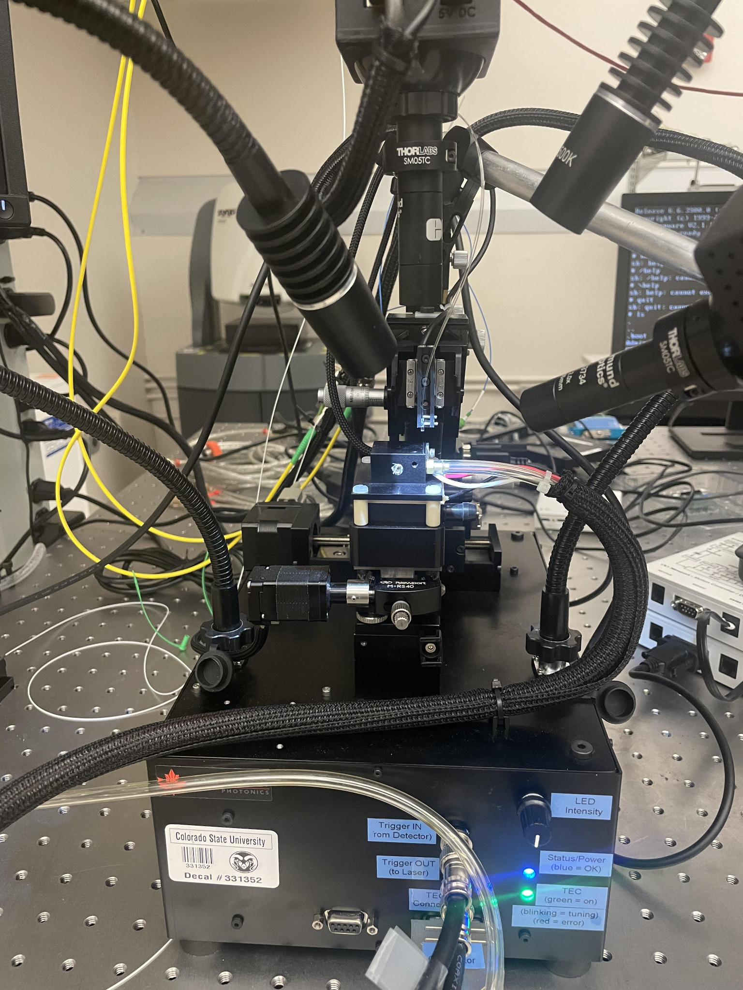

Figure 1: Maple Leaf Fabricated Automated Test Bench

Next as for the various subsystems involved in the MLP test bench. Figure 1 shows that the device has two cameras, one is an overhead camera that uses a 300mm lens, the other is a side profile camera with a 600mm lens. Through the use of the testing bench, the overhead camera was most useful when doing large shifts in the X and Y direction. While the side profile camera was much more useful for angle alignment and to change the Z position. Both of the camera's focal alignment can be manually changed with an allen wrench. It should be that this process can be tedious as the focal point is very sensitive to a turn of the allen wrench and while switching the exact position that the side camera is aimed at can become misaligned.

Figure 1 also shows that the chip stage and fiber stage are two separate modules in the sense that they both can be moved independently of each other. Through testing this was found to be extremely important as this makes alignment of the fiber and a specific device on the chip much easier. As for the actual positions that can be changed from each stage the fiber stage can be moved in the X, Y and Z positional directions. The fiber itself can also have the angle at which it is incident with the chip stage changed. The chip stage has X, Y and Z positional controls in addition to pitch, yaw and roll angle controls. The angle controls make it so that the chip can be at a flat position relative to the fiber stage. It also has a yaw control to allow for the chip stage to be aligned with the fiber stage such that the chip is normal to the fiber.

It can also be seen in Figure 1 that the MLP test bench includes two overhead lights that are controlled with a dial labeled LED Intensity. These two lights use ‘gooseneck’ arms so that the direction of that point can be adjusted manually by the user. In our testing it became apparent that by changing the direction and intensity of light the visibility of the chip and fiber in the two cameras could change dramatically. It should be said that once the light is mounted in an ideal position it does not need to be changed but changing the intensity depending on which camera is being used is a necessity. The main reasoning being that the side camera relies much more heavily on being able to see the shadow of the fiber stage on the chip stage for proper alignment. Meaning that a higher intensity is needed for better contrast to discern the chip stage from the fiber stage.

Figure 1 also shows a LED to indicate the use of a Thermo Electric Coupler (TEC). A TEC is a module that sits at the bottom of the chipstage. The TEC uses an applied voltage to either provide cooling or heating. When the TEC is paired with a Proportional Integral (PI) controller a targeted temperature can be set and the controller can change this applied voltage to have the chip stage hold a consistent temperature. The PI controller will constantly hold this temperature even with fluctuation within the room temperature. This is an important component of a photonics testing bench as the temperature of operation can change the optical properties of the tested chip, which in turn will cause variations in the expected output of devices. This parameter is set within the MLP software and can even be swept in needed for a test.

Next, there are also some clear plastic tubes coming out of the chip stage of the device shown in Figure 1. This clear plastic tube is attached to a vacuum that is manually operated. The purpose of this vacuum is to use suction to hold down the chip to the chip stage. The docking area for which the chip sits on the chip stage has a hole that this vacuum tube is attached to. This suction force allows for the various positional controls to take place without worrying about the chip sliding or moving from its original alignment position.

Now that the physical systems on the MLP test bench have been characterized, the next section will look into using the MLP software that came with the test bench. We started by reviewing the user manual, here we learned about the initialization sequence that the test bench uses to register a device. It uses a file that has a schematic of all of the devices on a photonic chip. The schematic includes X and Y coordinate locations and their relative distances throughout the chip. The schematic also provides the MLP system with specific names for each device.

After designating the chip that is being tested, the next step is to calibrate the test bench such that it can perform automated testing sequences. This process involves a couple of steps first. The chip stage needs to be verified that the chip is level when compared to the fiber stage. This is necessary because if not done properly then the fiber stage could scrape the chip if it is not level. To do this the fibers z position is recorded at three different corners of the chip. If the measurements are within ±5um of each other then this is within tolerance and can be verified as level. If not then the pitch and roll of the chip stage needs to be changed until this step is accomplished. After the chip stage is verified to be level now it is important to test three different devices on the chip to optimize the angle of incident between the fiber and the chip. This ideally is done at three corner devices to get the largest variation across the chip. This process can be somewhat tedious as there are several parameters that can be changed to minimize the loss of the chip. These parameters are the angle of the fiber, the yaw of the fiber stage, and as well as checking if the chip itself has particulates causing loss. After an angle of the fiber is chosen, the yaw is chosen, then a raster scan is run to find the exact position of the device. Figure 2 shows the results from this raster scan. Each one of the white dots shown in Figure 2 shows a device on the chip. The raster scan sweeps an area 200um in the y direction and 600um in the x direction. It turns on the laser module and the specific power and wavelength that the laser runs at can be set. The white dots represent the intensity that comes back through the fiber array.

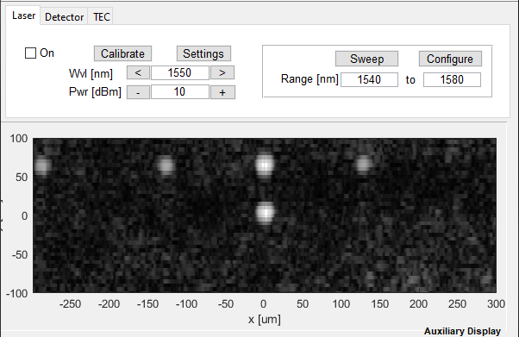

Figure 2: Results From a Raster Scan in the Maple Leaf Software

After a device's relative location is found the next step is to check to see if the optimized parameters are giving a higher or lower amount of loss. This is done through a fine align scan shown in Figure 3. It can be seen that the fine align scan sweeps the x direction for 20um at a higher fidelity. This is done to find the exact position of the device which gives the least amount of loss. Once a relatively low amount of loss (the lowest we found through experimenting was -17dB) the process of finding a coroner device and running a fine align scan is repeated at two different corners of the device. If the amount of loss is within ±0.5 dB then you have successfully calibrated the device and it is ready to run a full test of the chip testing each device.

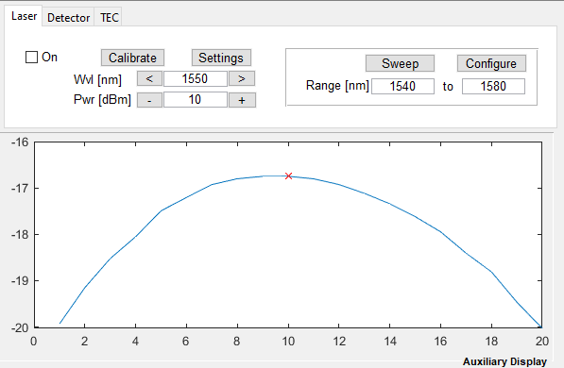

Figure 3: Results from a Fine Align Scan in the Maple Leaf Photonic Software

**Chapter 2.2 HARDWARE TO BE USED IN DESIGN:**

For this project the ECSyD Lab was able to acquire a donation from HPE, located in Fort Collins. This donation included linear motion stages, motor controllers, lab tables, cameras, meteorology profilers, power supplies, various pneumatic subsystems, etc. We were advised to look through the lengthy donation and see what was essential for the use of the automated testing bench. To accomplish this we first needed to know the essential functions of the test bench, which was covered in the previous section. Then we needed to know the use case and tolerances of each device. From this information we then would know how to integrate them for an overall comprehensive design of the test bench.

To start characterizing the different devices and systems that HPE donated we began with researching and finding any information online for each device. Much of the information found here was datasheets, tolerance spec sheets, and configurations. From here we also started contacting manufacturers if there were questions about the usability of a specific device or group of devices. This is when we discovered that many of the linear motion stages originated from Nanosystech, and after some correspondence between their technical support team. It was found that the specification sheets for these motion stages do not exist as Nanosystech uses them for their own integrated systems. This meant to find the viability of using these motion stages would require physical testing. In this stage we also discovered that many of the motor controllers were from a company called Aerotech [2]. When contacting them we learned that there was proprietary software that we would need access to in order to use these motor controllers. From here we managed to contact HPE and set up some meetings in order to find out how they used these devices in their lab, which would give us guidance into which devices we should choose to implement. As well as try to find a way to gain access to this proprietary software such that we can avoid switching the motor controllers for several devices.

These meetings and correspondences gave us several insights into how to use the various devices for our final design of the photonics test bench. Mainly we learned that the Hexapod, shown in Figure 3, was preset and was originally used through an interface software named LabVIEW. This was a key finding as we have access to LabVIEW and because the Newport Hexapod has motion capabilities in all six of the 3D directions. This makes it capable of handling one of the optical fiber stages alone. Another key insight that we learned from this meeting was that the pneumatic system included with the donation was used for moving chips from fabrication to their testing bench. This means that the pneumatic system is not likely usable for our testing bench. Finally, we were able to acquire the computer that HPE was using to run their test bench which has the Aerotech software installed. This allows us to use the Aerotech motor controller.

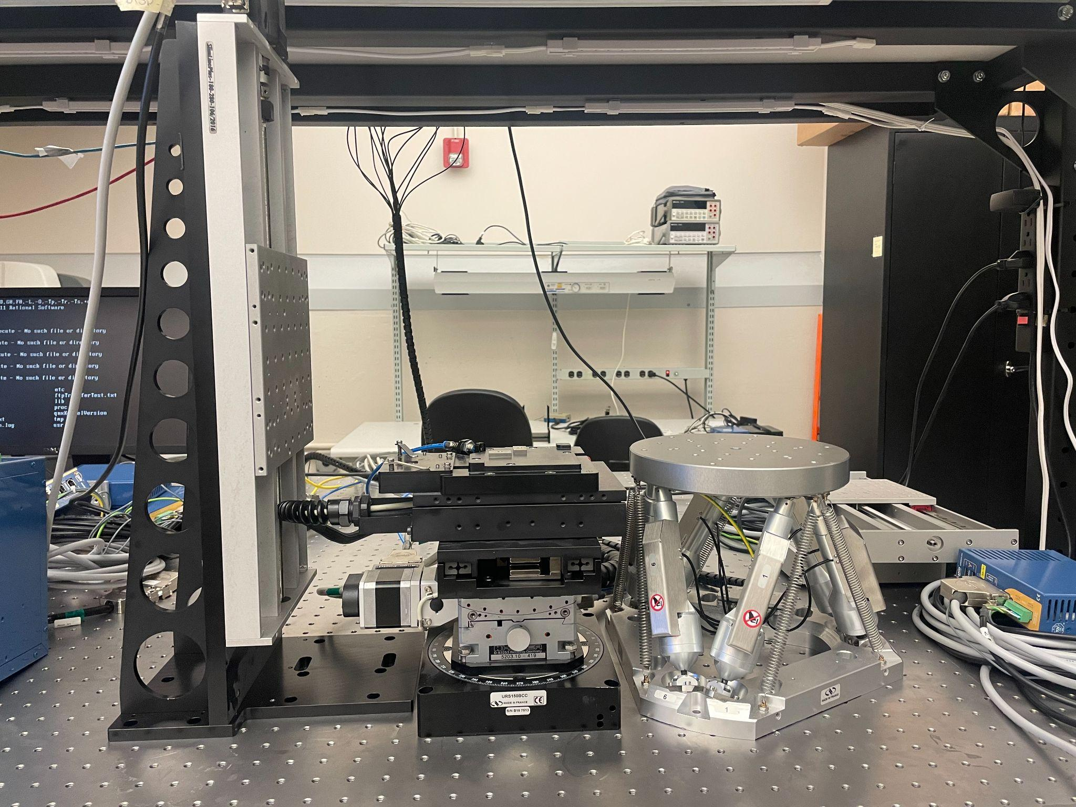

Figure 3: Newport Hexapod - HXP 100P - MECA

Based on all of these findings we decided to build the testing bench with the equipment listed in Table 1. As can be seen by Table 1 we decided to use 3 power supplies. This choice was made based on the spec sheets of the decided materials and their rated voltage and currents. It can also be seen that linear motion and rotary motion stages were chosen. This was done to achieve the various positional controls that are necessary for an automated testing station. The subsequent motor controllers for these motors were also chosen from the donations list to be added to the testing station. There was also a camera chosen to be used because of its high fidelity and focal length. Finally we chose to use the optical table and associated compressor as this limits the variation of testing due to testing. As this optical table creates an air boundary between it and the ground which drastically reduces vibration noise. It should be mentioned that the optical table was used when taking a baseline test of the MLP system to limit inconsistencies and to also improve the output of the MLP system.

| Category | Quantity | Equipment Description | Manufacture | Model |
| --- | --- | --- | --- | --- |
| Power Supply | 2 | Power Supply - Programmable | Sorinson | DLM 60-10 |
| Power Supply | 1 | Power Supply - Programmable | Sorinson | DLM16-185E 502 |
| Motion | 1 | Hexapod | Newport | HXP 100P - MECA |
| Motion | 2 | Linear motor translation stage | Nanosystec | Nanomove 100/2019/025 |
| Motion | 1 | Linear motor translation stage | Nanosystec | Nanomove 50/2015/027 |
| Motion | 5 | Motion Controller | Aerotech | A3200 Ndrive MP |
| Motion | 1 | Motion Controller | Aerotech | A3200 Ndrive CP |
| Motion | 2 | Motion Controller | Newport | SMC100 |
| Motion | 1 | Motion Controller | Newport | Conex - CC |
| Motion | 1 | Motorized rotary stage | Newport | URS100BPP |
| Camera | 1 | Microscope Camera | Motic | Moticam 580 |
| Table | 1 | Air Compressor | Newport |  |
| Table | 1 | Optical table | Thorlabs | Nexus |

Table 1: Components Used in Final Design from HPE Donation

**Chapter 2.3 HARDWARE SETUP:**

In this section we will briefly discuss the general setup of the hardware provided. A diagram of the system setup can be seen in Figure 4.

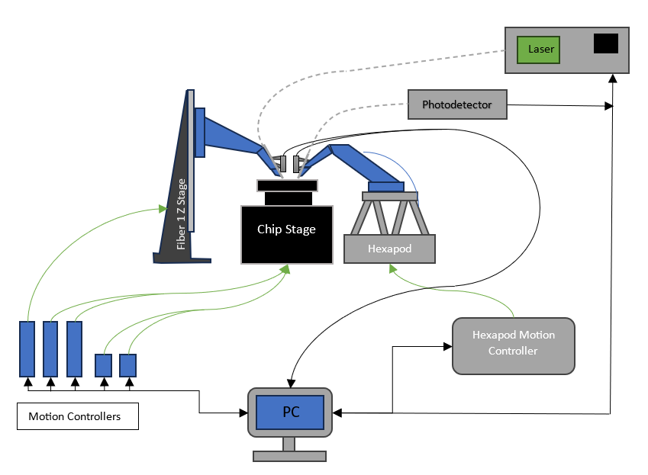

Figure 4: Hardware Setup Diagram

As can be seen above, the hardware setup revolves around a central lab PC. A server machine acquired from HP on December 6th will be used to control the hardware and provide a user interface during use. It is important to note that this control PC never directly interfaces with any of the motors and instead uses the motor controllers for control of the chip stages.

For the interconnection of the motor divers, laser, and PC, many different cables are used. Three of the motion controllers used are from Aerotech and rely on a Firewire connection to interface with the host PC, while using a proprietary cable to connect with their motors. The Newport Hexapod relies on a network interface or ethernet connection to communicate with the host PC. Finally, the laser relies on a simple USB interface.

Since we are using two fibers for this design instead of a single fiber array, we require both fibers to have 6-axis control for proper alignment. However, the Newport Hexapod is the only device available to us that has a complete 6-axis of movement. Luckily, the chip stage itself provides 5-axis control with the exclusion of a Z height axis which can be provided with the Fiber 1 Z Stage in the figure above.

The fiber arms (shown in blue in Figure 4), have yet to be designed or fabricated. Their design and fabrication timelines are detailed in Appendix C. The purpose of these arms are to support the fiber connections as well as two cameras which will be used for manually calibrating the fibers,

**Chapter 2.4 Software Used:**

In the development of our automated photonic testing station, the integration of specific software systems was crucial to manage and control various hardware components effectively. These systems included LabVIEW, Aerotech's A3200 Motion Composer software, and the Hexapod Web Interface, each serving a unique role in the project.

A3200 Motion Composer by Aerotech:

This software was instrumental in controlling the Aerotech motors responsible for the Z movement and chip stage adjustments. The system was designed to provide precise control over the motorized stages, essential for aligning the photonic devices accurately during testing. However, we faced significant setbacks as the configuration and setup files required for the software's operation were missing. These files had been inadvertently deleted by the HPE, which complicated the setup process.

LabVIEW:

LabVIEW is a robust programming environment allowing for the integration of various hardware components through a user-friendly graphical interface. Therefore, it is selected as the primary control platform, which is utilized for managing all functions of the testing station. However, installation of LabVIEW posed significant challenges due to the operating system limitations of the donated computer, which runs Windows 7. The Engineering Technology Services (ETS) department declined to install LabVIEW on an outdated operating system, citing support and compatibility concerns.

Hexapod Web Interface:

The Hexapod system, controlled via a web interface, was used for managing the second fiber arm. This interface was critical for adjusting the hexapod's six axes—x, y, z, yaw, pitch, and roll—which are essential for the precise positioning of the fiber arm. The interface's comprehensive control options facilitated movements around a set pivot point, enhancing the testing station's functionality. The system was linked to a Newport motion controller, ensuring seamless operation and user-friendly interaction for complex positioning tasks.

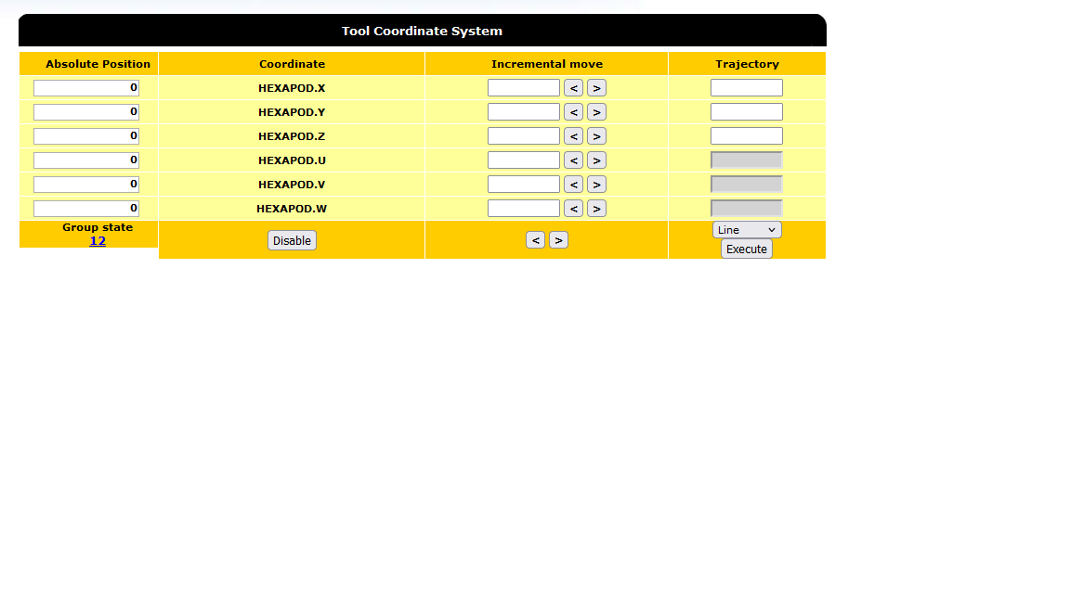

Figure 4: Hexapod web interface

The integration of these software systems was vital for the automation and functionality of the photonic testing station. Each piece of software brought unique capabilities to the project, ensuring that the hardware components worked in harmony to achieve precise testing and measurement of photonic devices.

**Chapter 3. STANDARDS AND TOOLS:**

In this chapter we will discuss the standards that apply to our project as well as the tools that we used in conjunction with our hardware.

**Chapter 3.2 STANDARDS:**

Due to the nature of our project being largely reverse engineering the previous labs setup, there are relatively few standards that we needed to abide by. However, we have had a few standards regarding our organization of documentation. For instance, our group’s shared One Drive has an organized structure used for storing the documentation for each device donated to us. In this folder is a series of other folders containing the documentation found for a device as well as an ID we assigned to it. This ID corresponds to a label printed on each physical component so that a person can simply grab the device ID and quickly locate its documentation within the OneDrive.

To a lesser extent, we also needed to comply with USB, FireWire, and RS-232 communication protocols in order to interface with many of the devices. However, most of these interfaces are handled by already existing libraries and required little to no effort on our part to uphold.

**Chapter 3.2 TOOLS USED:**

The following is a table of tools that we used/will use as well as the purpose they fulfilled:

| Tool: | Related Hardware: | Use: | Notes: |
| --- | --- | --- | --- |
| HXP Web Interface | HXP100 Hexapod | Position Control of Hexapod. | Allows for remote wireless control of Hexapod |
| CLR Python Library | Newport Motion Controllers | Motion Control of backup chip stage. | Uses a DLL file supplied by Newport for control functions |
| Aerotech A3200 Software | Aerotech A3200 Motor Controllers | Interfacing with Aerotech Motor | Missing Files |
| LabVIEW | n/a | Provides a user friendly interface | Unable to have it |
| Jira | n/a | Project organization and tasks. | This was used in our first few weeks before transitioning to using google slides instead |
| One Drive | n/a | Documentation sharing and organization. |  |
| GitHub | n/a | Revision control of data cleaning scripts. |  |

Table 2: Tools Used with Purpose and Related Hardware

### Chapter 4. CONCLUSION:

In conclusion, the approach to completing the task of designing and implementing an automated photonic testing station has been shown throughout this report. We have shown how we characterized what is necessary for a functioning test bench through the exploration of the commercially made MLP test bench. We also showed how we determined the hardware necessary to complete this task. This was done through thorough research as well as some preliminary testing of the equipment. We finally created a final design and began interacting with various subsystems to ultimately integrate them all into a fully functional automated testing bench. There are still some lingering questions as to this integration step. Mainly how will all of the various subsystems interact with our planned use of LabVIEW. There also may be some questions about various data processing techniques that will need to be implemented in order to allow for the testing station to be automated. These concerns will be addressed in the following sections as to plan out for the upcoming semester.

### Chapter 5. FUTURE WORK:

As we transition into the next semester, our focus will shift from the initial phase of research and understanding of the current working testing station to the more hands-on and constructive phase of building our new testing station. This next phase is crucial as it encompasses the application of our accumulated knowledge and the actualization of our design concepts.

### Chapter 5. OBJECTIVES FOR NEXT SEMESTER:

1. Interface with Aerotech Software

Our primary objective will be to establish a robust interface with Aerotech software. This software is pivotal for controlling and managing the motion systems in our testing station. We will focus on developing a customized interface that allows for precise control and synchronization with our photonic devices. This will involve detailed programming and testing to ensure compatibility and efficiency.

1. Learn LabVIEW

Concurrently ,we will be dedicated to learning LabVIEW, a system-design platform and development environment. This skill is essential for our project as LabVIEW will be used extensively in interfacing and automating various components of our testing station.

1. Interface All Devices Using LabVIEW

Once proficient in LabVIEW, we will commence the integration of all devices using this platform. Our goal is to have a unified control interface for all components, including light sources, detectors, and motion control systems. The integration will be meticulously planned and executed, ensuring that all devices communicate seamlessly and function cohesively.

1. Design Arm for the Fiber

A significant engineering challenge will be designing a mechanical arm for maneuvering the fiber. This arm must be precise, stable, and compatible with our testing station's spatial constraints. The design phase will involve 3D modeling, simulations, and iterative prototyping to achieve the desired accuracy and functionality.

1. Interface with the Laser

An integral part of our project is interfacing with the laser system. This involves not only physical connections but also ensuring that the software can control and adjust the laser parameters according to our testing needs. This phase will require careful calibration and alignment to ensure optimal performance and data accuracy.

1. Create Software Platform

Finally, we will develop a comprehensive software platform. This platform will not only control the testing station but also provide an intuitive user interface for monitoring, data analysis, and reporting. The software will be designed with scalability and flexibility in mind, to accommodate future upgrades and enhancements.

In conclusion, the next semester's work will be pivotal in bringing our integrated silicon photonic testing station from a conceptual stage to a fully functional prototype. Each of these phases will require a concerted effort from our team, combining skills in software development, mechanical engineering, and photonics. We are committed to overcoming these challenges and achieving our project goals.

## REFERENCES:

[1] Maple Leaf Photonics. MLP. (n.d.). https://www.mapleleafphotonics.com/

[2] *Precision Motion & Automation Company: Aerotech*. Aerotech US. (2023, November 13). https://www.aerotech.com/

## APPENDICES:

**Appendix A. ABBREVIATIONS:**

CMOS - Complementary Metal-Oxide Semiconductor

DLL - Dynamic Link Library

HPE - Hewlett Packard Enterprises

ECSyD - Electronic Photonic Systems Design

MLP - Maple Leaf Photonics

PC - Personal Computer

PI - Proportional Integral

PIC - Photonic Integrated Chip

TEC - Thermo Electric Controller

**Appendix B. BUDGET:**

Throughout the semester the budget had to be changed significantly, mainly due to the original budget being contingent on a few key factors. Those factors being whether or not we were able to gain access to the Aerotech proprietary software. In the case that we were not able to gain access to the Aerotech software and we chose to find a replacement for 5 motor controllers which was estimated at $1,250. This gives a total planned budget of $1325.51. In the case that we were not able to gain access to the Aerotech software and we chose to purchase the software. The software itself was given a quote by an Aerotech representative of $4,750 which would give a total planned budget of $4,825.51. In the case that we are able to gain access to the Aerotech software then our total planned budget for the semester would come to $75.51.

Since we were able to acquire the Aerotech software our total budget for semester one was $75.51, this total can be seen in Table 3. As can be seen the purchases made this semester were mainly screws, cables and adapters. These purchases were made this semester to allow the team to work on connecting and interfacing with specific devices before an overall integration. The shipping and handling concerns were mitigated by using an amazon prime account with our graduate advisor. This allowed us to mitigate the costs of shipping as well as allow for us easier refunds and returns in the chance of a defect.

| Date When Needed | Component | Price per unit | Quantity | Shipping & Handling | Total | Lead time |
| --- | --- | --- | --- | --- | --- | --- |
| 11/6 | 12 x 12mm screws for the optics table. | $10.10 | 1 | $0.00 | $10.10 | 2 days |
| 10/6 | Crossover ethernet cables | $10.00 | 1 | $0.00 | $10.00 | 7 days |
| 11/12 | USB-FlyWire | $3.00 | 8 | $0.00 | $24.00 | 14 days |
| 11/12 | RS232-USB | $2.00 | 6 | $0.00 | $12.00 | 12 days |
| 11/12 | USB-Wifi Adapter | $4.00 | 1 | $0.00 | $4.00 | 14 days |
| 01/20 | M6 Screws | $10.00 | 1 | $0.00 | $10.00 | 14 days |
| 11/6 | PS2-USB | $5.00 | 1 | $0.00 | $5.00 | 14 days |

Table 3: First Semester Budget

**Appendix C. TIMELINE:**

Timeline 1:

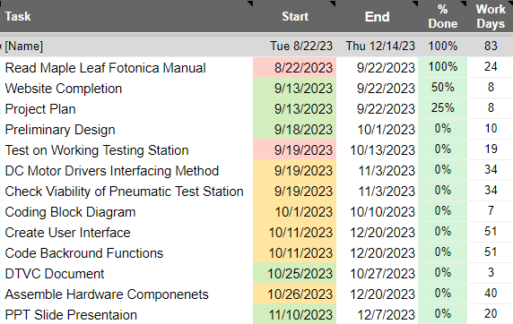

Timeline 2:

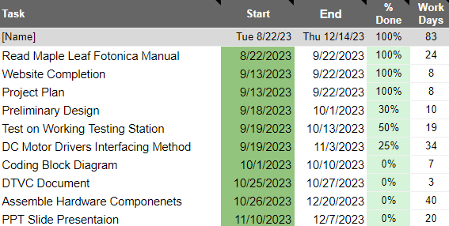

Timeline 3:

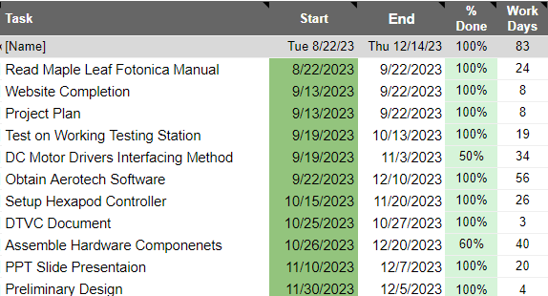

Second Semester Timeline:

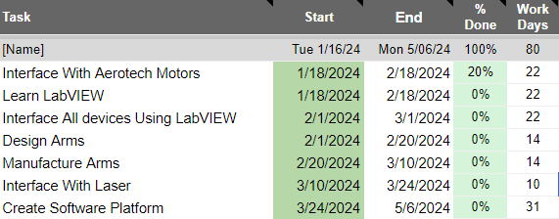

## ACKNOWLEDGMENTS:

We would like to thank a number of important people and organizations who have played pivotal roles in our project.

We are indebted to Professor Mahdi Nikdast for his technical assistance and advice which he generously provided . The depth of his knowledge and his commitment has played a crucial role in our education, as well as in our professional development.

Also, we would like to appreciate Mr. Biag who is also our graduate advisor. He has provided us with continued support, his valuable suggestions, and insight, which greatly helped us navigate the difficulties involved in this project.

In addition, we would like to thank HPE for their exceptional donation. By giving us all of their donation for equipment and resources, we are able to stand on this project today. This would not have been achieved without their help.